

Mentoring, Training & Placements Department
Daily Report 26-03-2026
Description |  | Total to be received | Received till Date | Received Date | To be received

II | Staff Attendance
S.No | Dept. | Category | On Rolls | Absent | DQI | DQI Performance | Overall DQI | Overall Performance
1 | MTP |  | 8 | 0

 | III. Students’ Attendance:
IV | MTP:  SAMUEL  - AMBIANZ India Pvt Ltd has selected 4 students for Full time employment with a package of 3.00 LPA.  - Civil - 3  - Mech - 1  - Infosys IQE interviews - test cleared students have In-person interviews at Gachibowli office on 31st March. Informed students.  - ENG Unit - 17 students who are selected for eng unit have a virtual session on 28th Mar at 11 AM. Informed students.  - DBS for 2027 batch - They are considering CSE, IT and AIML. 616 students are eligible for the process. Online test is scheduled on 27th during 5 PM to 8 PM. Coordinating with Departments and students.  KABITA  - DTCC: 4 Students selected from Batch 2027 for DTCC Internship. During Internship stipend 50 K, after FTE 10.12 LPA. Internship joining from 25th May-2026 @ Chennai location.  - Moschip: Opportunity for batch 2026, 39 ECE students registered for the process, data shared with HR team  - Incedo: Incedo on-campus interviews are in progress, Incedo on-campus Pre-placement talk session by Ms. Sakshi, TA & Sr. Leadership Team shared the details with students.  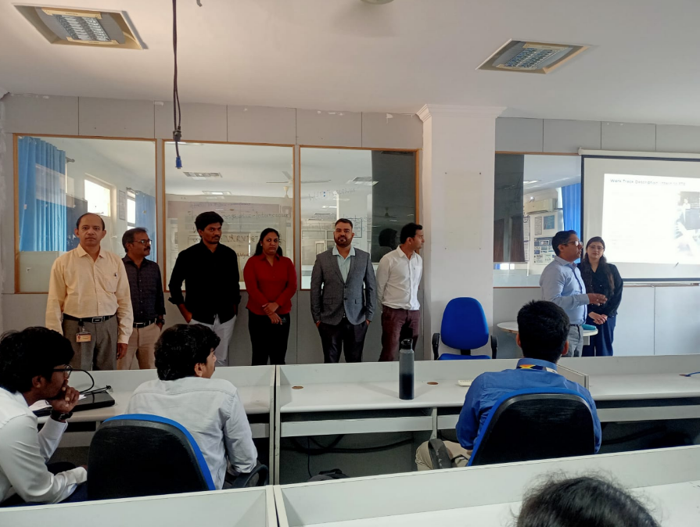 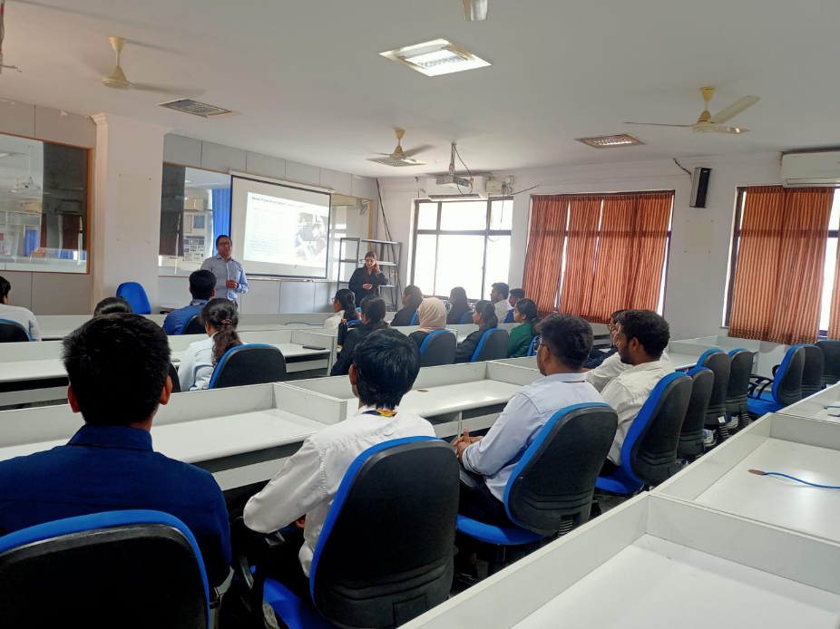 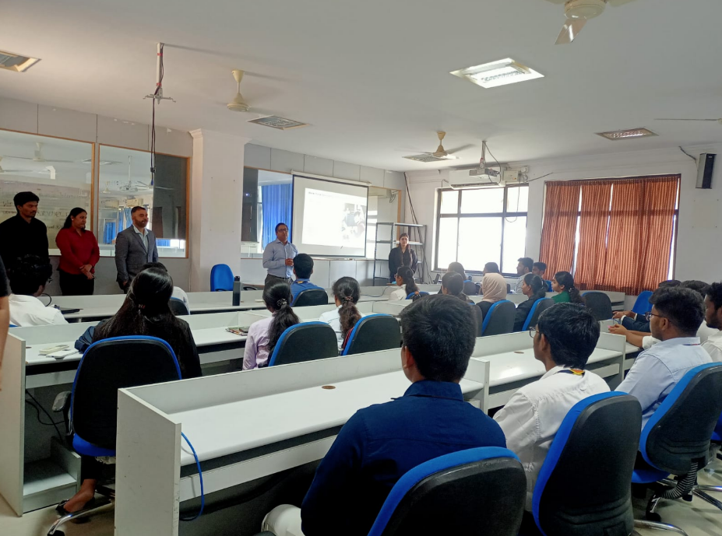  V HOD-CSE (CSDS&AIDS):  VI HOD-IT:  VII HOD-ECE:  2025 2026 Batch Plis open Summary:  CSE CSBS AIML IOT DS CyS AIDS IT ECE EEE EIE ME CE AE M.TECH TOTAL  359 65 276 85 187 63 65 249 207 83 92 57 62 19 18 1887  2025
VIII Classwork Adjustment / Lectures Interchanged:
S. No. | Dept | Subject | Adjusted from | Adjusted to

IX. Participation by Staff/Students:
S.No | Name | Event | Status (delegate /paper)resent, speaker) | Date and  Duration

X | Particulars of Library Services or Transactions: | No.s

For Head of the Department.

